**Assessment**



**I213-Dynamic Web Solutions**

**Assessment One (Assignment)**

|  |  |  |
| --- | --- | --- |
| **Due Date**  Thursday - 9th August 2018 | **Faculty**  Humanities and Business | |
| **Due Time**  1pm | **School**  Business and ICT | |
| **Weighting**  25% | **Programme**  Bachelor of Information and Communications Technology (Applied) | |
| **Submission Method**  Moodle online upload of the documentation and website.  Present prototype to lecturer in class. | **Learning Outcomes Assessed**   * Design and document a Web Application | |
| **Conditions**  This is an individual assessment all work must be your own.  To pass this assessment, you may also be asked to adequately explain aspects of your assignment to the lecturer. |  | |
| **Lecturer**  Richard Dargie | | **Moderator**  Graeme Richards |

# Assignment Requirements

1. Given the design documentation provided, you must interpret the documentation, and complete the following:

* For each of the components provided, fill in the table specifications where applicable and where appropriate, add additional details.
* From your design specifications, construct a webpage prototype using the components to match as close as possible, the screenshots provided from one of the following HTML/CSS frameworks:
  + Bootstrap 4 <https://getbootstrap.com/docs/4.1/getting-started/introduction/>
  + Foundation 6 <https://foundation.zurb.com/sites/docs/index.html>
  + W3.CSS <https://www.w3schools.com/w3css/default.asp>
  + Materialize <https://materializecss.com/getting-started.html>
* Update your design table specifications as your prototype progresses.
* Unless previously discussed with the lecturer, your prototype will be accessed on the Lab computers so **please test your layouts on these monitors**.

1. You must use *CSS Grid* to create the page layout as per the design documentation provided. Failure to use this will result in a failed assessment. (You can use your own *grid area* names)
2. You must use the two images provided.

# Assignment Marking

The grading for this assessment will be as follows:

**To obtain a C Grade.**

* You have completed the table specifications for each component and have made a reasonable attempt for each (lecturer’s discretion).
* You have used CSS GRID for all of the layout.
* You have used one of the HTML/CSS frameworks above for your components.
* Your prototype has **no more than three** of the following problems: (lecturers discretion))
  + Component alignments (do not match the screenshots
  + Spacing (padding/ margins) are not consistent.
  + Centered Vertical alignment between components (filter section and top nav section)
  + Images not appearing as indicated (especially the header background)
  + CSS Grid layouts are not applied as per the requirements.
  + Layouts do not closely match the screenshots provided.
  + Colours no not match the screenshots provided.
  + Spelling is not as shown from the screenshots provided.
* You have adequately answered any questions that may be asked about the assessment you have submitted.

**To obtain a B Grade.**

* You have met the requirements for a **C Grade.**
* You have **no more than two** of the problems outlined in the C Grade criteria.

**To obtain an A Grade.**

* You have met the requirements for a **B Grade.**
* You have **no more than one** of the problems outlined in the C Grade criteria.

**To obtain an A+ Grade.**

* You have met the requirements for an **A Grade.**
* You no apparent problems as outlined in the C Grade criteria.

# Assignment Submission

1. Replace the proposed Web page screenshot shown in *Figure 1.* below, with your own prototype screenshot.
2. Create a folder and place within it, this entire document (with your screenshot).
3. Within the same folder, add your website prototype.
4. Zip (not .rar) the folder with your name on it, and upload to Moodle in the link provided.
5. When asked in class, download your assignment and present it to the lecturer for marking.

The Proposed Web page

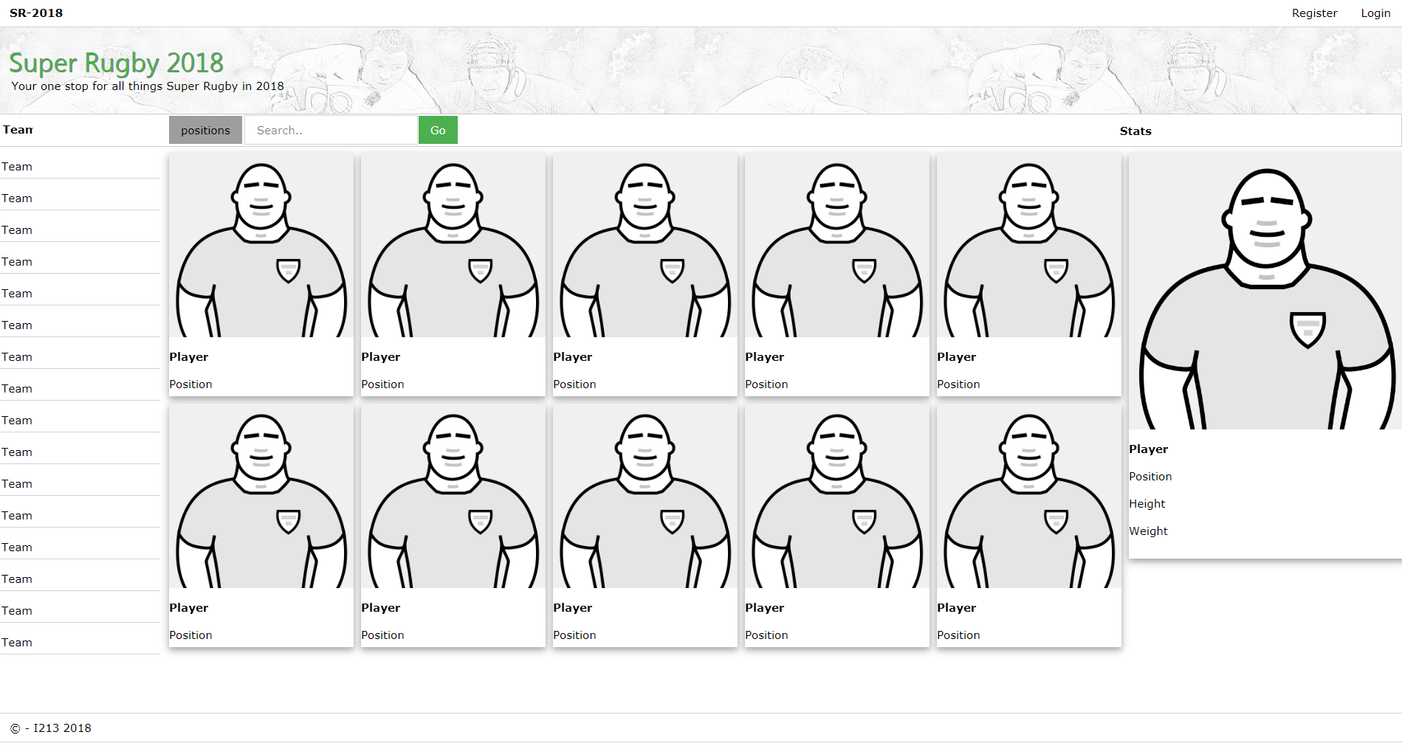

Figure 1 -The Web page when viewed in the Lab computers at full screen (1904p x 941px)

CSS GRID Specifications

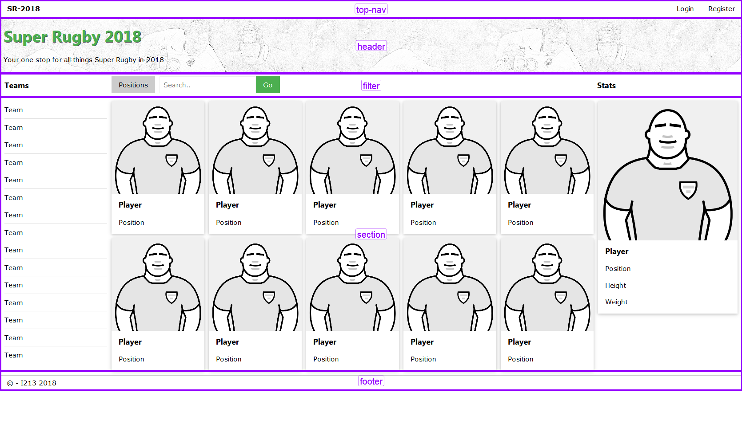

Figure 2-CSS GRID showing the main grid areas.

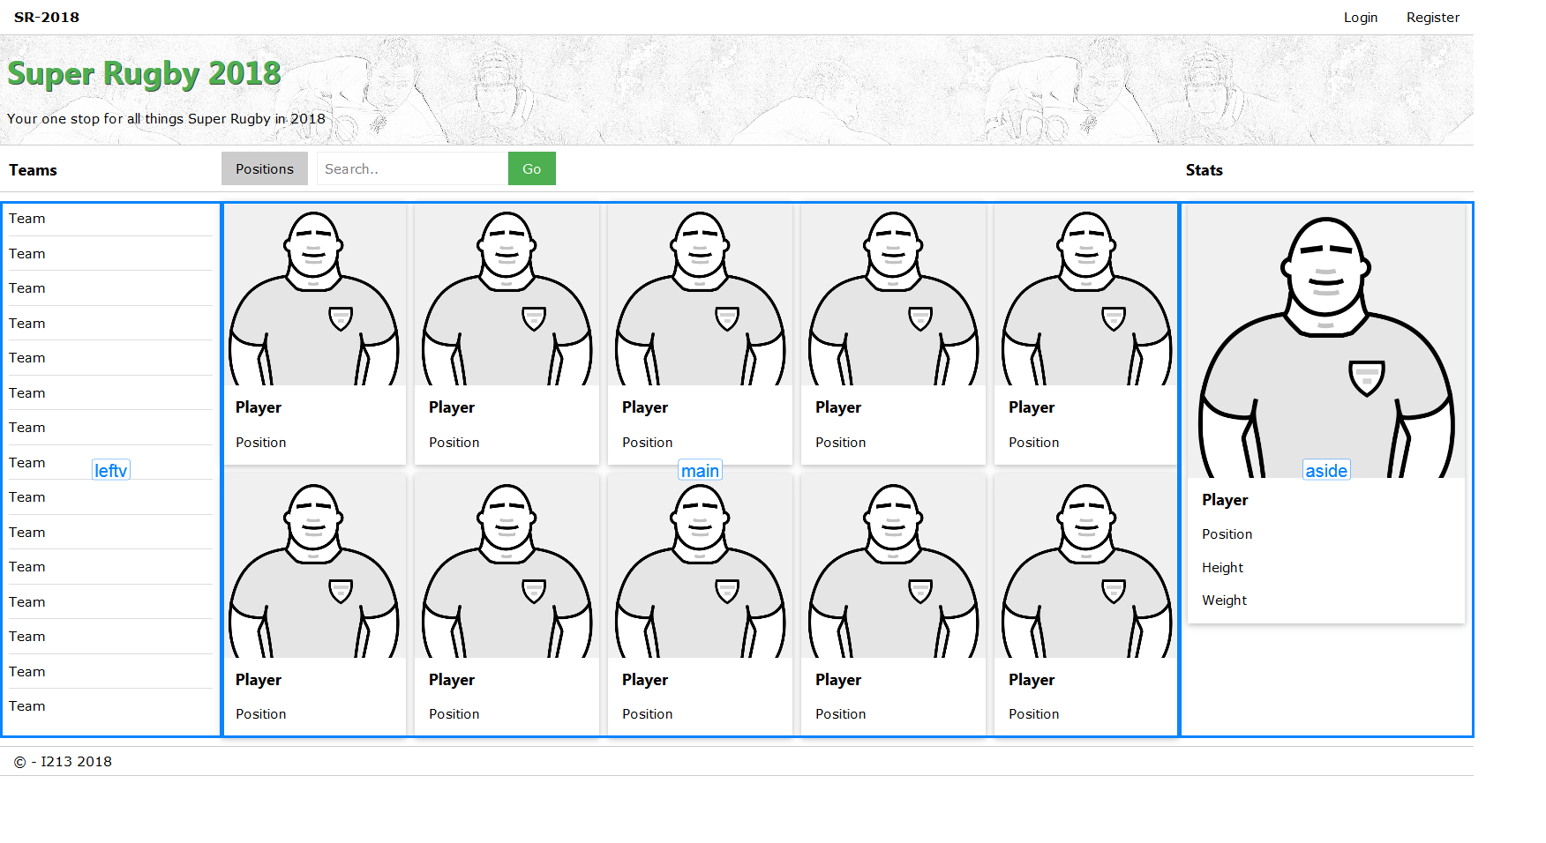

Figure 3-CSS GRID showing the section grid areas.

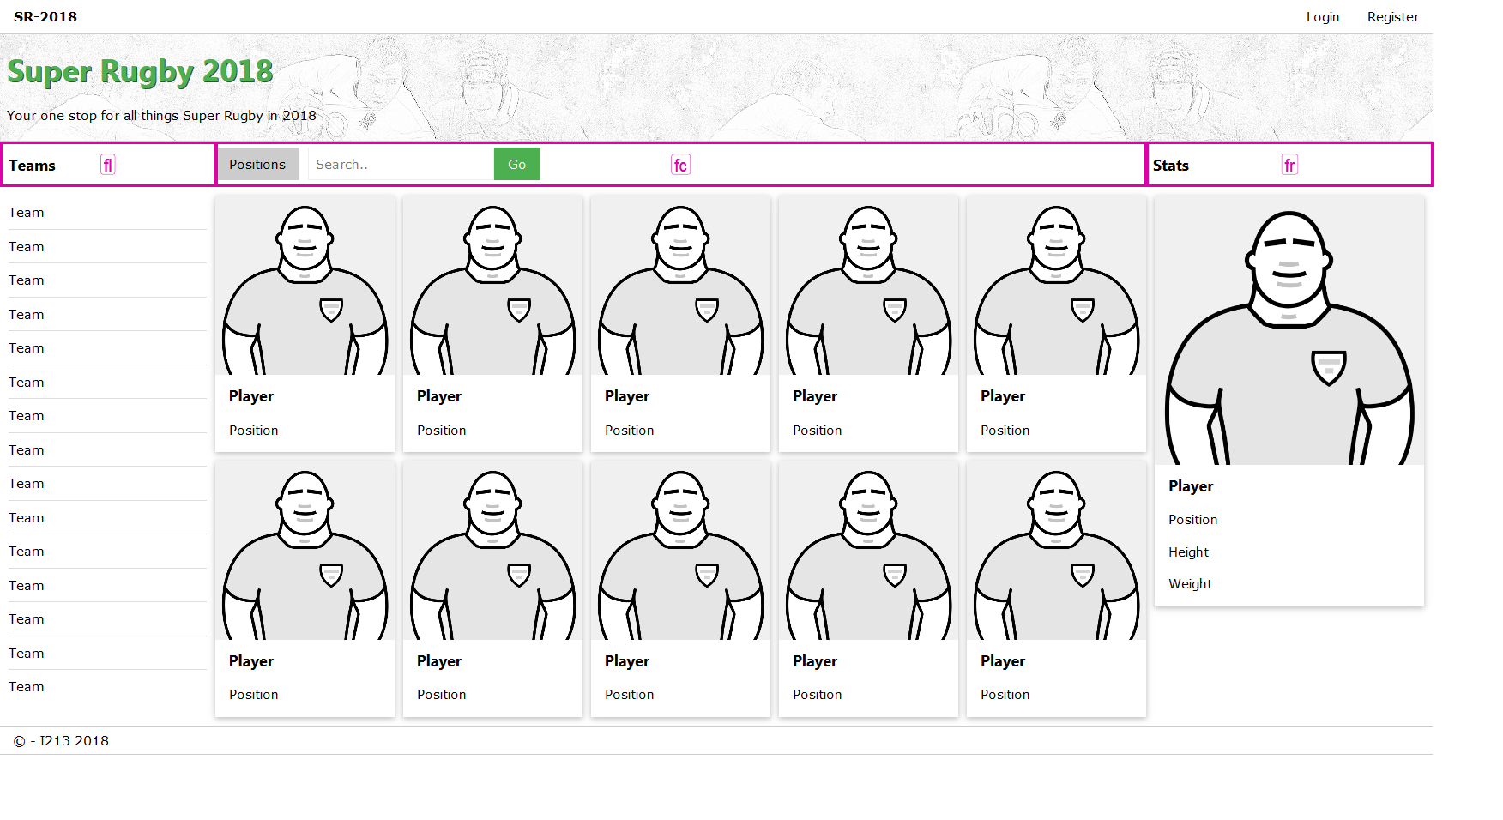

Figure 4 - CSS GRID showing the filter navigation areas.

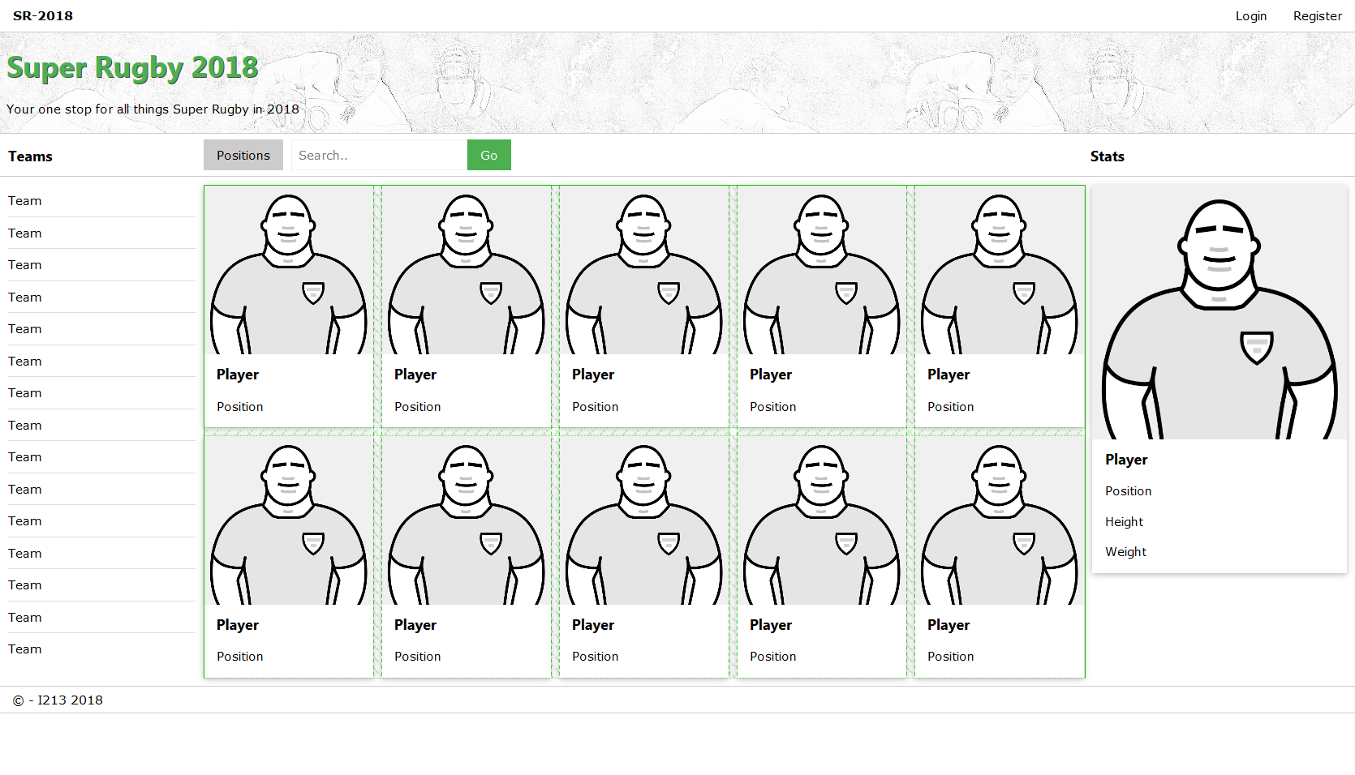

Figure 5 - CSS GRID showing the main sections grid (grid gap of 10px)



|  |  |
| --- | --- |
| **component type** | **navigation** |
| **id** | **top-nav** |
| **class/s** | **nav** |
| **width** | **100%** |
| **height** | **38px** |
| **background colour** | **#ffffff** |
| **background url** | **n/a** |
| **font family** | **n/a** |
| **font weight** | **n/a** |
| **font size** | **n/a** |
| **font colour** | **n/a** |
| ***add additional details as you need***  ***e.g. padding/margin*** | **…** |



|  |  |
| --- | --- |
| **component type** | text |
| **id** | top-nav |
| **class/s** | Button |
| **width** | auto |
| **height** | auto |
| **background colour** | n/a |
| **background url** | n/a |
| **font family** | Verdana,sans-serif |
| **font weight** | strong |
| **font size** | 12 |
| **font colour** | auto |

 

|  |  |
| --- | --- |
| **component type** | Navigation |
| **id** | Top-nav |
| **class/s** | "w3-bar-item w3-button" |
| **width** | auto |
| **height** | auto |
| **background colour** | n/a |
| **background url** |  |
| **font family** | Verdana(auto) |
| **font weight** | auto |
| **font size** | auto |
| **font colour** | auto |



|  |  |
| --- | --- |
| **component type** | Image |
| **id** | header |
| **class/s** | header-image |
| **width** | 100% |
| **height** | 120px |
| **background colour** | <div class="header-image-left"><img src = "img/header.jpg" alt = "header" style ="width:50%;" align ="left" height="120px"> </div> |
| **background url** | Set using html |
| **font family** | Verdana(auto) |
| **font weight** | auto |
| **font size** | auto |
| **font colour** | auto |



|  |  |
| --- | --- |
| **component type** | H1 |
| **id** | header |
| **class/s** | "bottom-left" |
| **width** | Auto |
| **height** | 100px |
| **background colour** | n/a |
| **background url** | n/a |
| **font family** | Verdana(auto) |
| **font weight** | auto |
| **font size** | auto |
| **font colour** | auto |



|  |  |
| --- | --- |
| **component type** | Text<p> |
| **id** | header |
| **class/s** | "header-under-text" |
| **width** | auto |
| **height** | 16px |
| **background colour** | n/a |
| **background url** | n/a |
| **font family** | Verdana(auto) |
| **font weight** | auto |
| **font size** | auto |
| **font colour** | auto |



|  |  |
| --- | --- |
| **component type** | nav-bar |
| **id** | filter |
| **class/s** | "w3-container" |
| **width** | auto |
| **height** | 45px |
| **background colour** | auto |
| **background url** | n/a |
| **font family** | Verdana(auto) |
| **font weight** | auto |
| **font size** | auto |
| **font colour** | auto |



|  |  |
| --- | --- |
| **component type** | Text |
| **id** | filter |
| **class/s** | "w3-bar-item w3-button” |
| **width** | 12% |
| **height** | auto |
| **background colour** | n/a |
| **background url** | n/a |
| **font family** | Verdana(auto) |
| **font weight** | auto |
| **font size** | auto |
| **font colour** | auto |



|  |  |
| --- | --- |
| **component type** | tetxt |
| **id** | filter |
| **class/s** | "w3-button w3-grey" |
| **width** | auto |
| **height** | auto |
| **background colour** | n/a |
| **background url** | n/a |
| **font family** | Verdana(auto) |
| **font weight** | auto |
| **font size** | auto |
| **font colour** | auto |

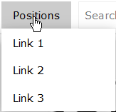

|  |  |
| --- | --- |
| **component type** | button |
| **id** | filter |
| **class/s** | “w3-dropdown-hover” |
| **width** | auto |
| **height** | auto |
| **background colour** | n/a |
| **background url** | n/a |
| **font family** | Verdana(auto) |
| **font weight** | Auto |
| **font size** | auto |
| **font colour** | auto |



|  |  |
| --- | --- |
| **component type** | Search bar |
| **id** | filter |
| **class/s** | w3-bar-item w3-input w3-white" |
| **width** | auto |
| **height** | auto |
| **background colour** | auto |
| **background url** | n/a |
| **font family** | Verdana(auto) |
| **font weight** | auto |
| **font size** | auto |
| **font colour** | auto |



|  |  |
| --- | --- |
| **component type** | button |
| **id** | filter |
| **class/s** | “ w3-bar-item w3-button w3-green" |
| **width** | Auto |
| **height** | Auto |
| **background colour** | #4CAF50 green |
| **background url** | Auto |
| **font family** | Verdana(auto) |
| **font weight** | auto |
| **font size** | Auto |
| **font colour** | auto |



|  |  |
| --- | --- |
| **component type** | text |
| **id** | filter |
| **class/s** | stats |
| **width** | Auto |
| **height** | Auto |
| **background colour** | auto |
| **background url** | n/a |
| **font family** | Verdana |
| **font weight** | auto |
| **font size** | 15px |
| **font colour** | auto |



|  |  |
| --- | --- |
| **component type** | text |
| **id** | leftv |
| **class/s** | < w3-bar-item w3-button w3-mobile" |
| **width** | auto |
| **height** | auto |
| **background colour** | auto |
| **background url** | n/a |
| **font family** | Verdana |
| **font weight** | auto |
| **font size** | auto |
| **font colour** | auto |

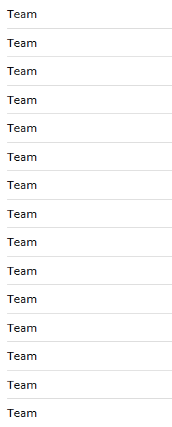

|  |  |
| --- | --- |
| **component type** | Aside list |
| **id** | leftv |
| **class/s** | div |
| **width** | 230px |
| **height** | 700px |
| **background colour** | auto |
| **background url** | n/a |
| **font family** | Verdana |
| **font weight** | auto |
| **font size** | auto |
| **font colour** | auto |

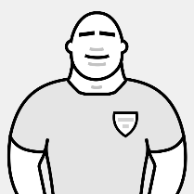

|  |  |
| --- | --- |
| **component type** | image |
| **id** | main |
| **class/s** | img |
| **width** | 250px |
| **height** | 300px |
| **background colour** | n/a |
| **background url** | Inserted with html <img src="img/player.png" alt="player"style="width:100%"> |
| **font family** | Verdana |
| **font weight** | auto |
| **font size** | auto |
| **font colour** | auto |



|  |  |
| --- | --- |
| **component type** | text |
| **id** | main |
| **class/s** | <p> Player</p> |
| **width** | auto |
| **height** | auto |
| **background colour** | n/a |
| **background url** | n/a |
| **font family** | Verdana |
| **font weight** | auto |
| **font size** | auto |
| **font colour** | auto |



|  |  |
| --- | --- |
| **component type** | text |
| **id** | main |
| **class/s** | <p>Position</p> |
| **width** | auto |
| **height** | auto |
| **background colour** | auto |
| **background url** | n/a |
| **font family** | Verdana |
| **font weight** | auto |
| **font size** | auto |
| **font colour** | auto |

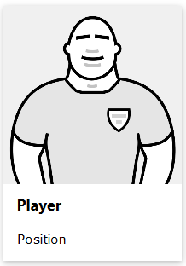

|  |  |
| --- | --- |
| **component type** |  |
| **id** | main |
| **class/s** | “w3-card-4" |
| **width** | 250px |
| **height** | 300px |
| **background colour** | auto |
| **background url** | n/a |
| **font family** | Verdana |
| **font weight** | auto |
| **font size** | auto |
| **font colour** | auto |



|  |  |
| --- | --- |
| **component type** | footer |
| **id** | Top-nav |
| **class/s** | w3-bar w3-white" |
| **width** | 100% |
| **height** | 20px |
| **background colour** | auto |
| **background url** | n/a |
| **font family** | Verdana |
| **font weight** | auto |
| **font size** | auto |
| **font colour** | auto |



|  |  |
| --- | --- |
| **component type** | footer |
| **id** | footer |
| **class/s** | "w3-bar-item” |
| **width** | auto |
| **height** | auto |
| **background colour** | n/a |
| **background url** | n/a |
| **font family** | Verdana |
| **font weight** | auto |
| **font size** | auto |
| **font colour** | auto |